**Title: Installing Ubuntu 22.04 LTS on Windows Using WSL2**

This recipe uses the **What – How – Why** format to guide you through setting up a Linux development environment on Windows using **WSL2 and Ubuntu 22.04 LTS** — the most widely used configuration for DevOps learners and professionals.

**🔸 What (Introduction & Theory)**

This recipe teaches how to set up a complete Linux environment (Ubuntu 22.04 LTS) on a Windows system using **Windows Subsystem for Linux version 2 (WSL2)**. WSL2 allows you to run a real Linux kernel inside Windows — without dual-booting or using resource-heavy virtual machines.

It covers three essential tasks:

1. **WSL2 Installation** – Ensures Windows can host Linux environments natively using virtualization.
2. **Ubuntu 22.04 Setup** – Installs the most common LTS version of Ubuntu, used by most DevOps tools and cloud servers.
3. **Default Distro Configuration** – Makes Ubuntu 22.04 the default Linux for all WSL commands and terminals.

These three steps are critical for preparing a Windows system for real-world DevOps training and practice. WSL2 removes the need for external VMs. Ubuntu ensures compatibility with Docker, Kubernetes, and Ansible. Setting the default distro streamlines daily Linux usage.

**🔸 How (Step-by-Step Process)**

**________________________________________**

**Part 1: Install Ubuntu 22.04 LTS with WSL2**

**Step 1: Open PowerShell as Administrator**

* Press Windows + S, type **PowerShell**.
* Right-click → select **Run as Administrator**.

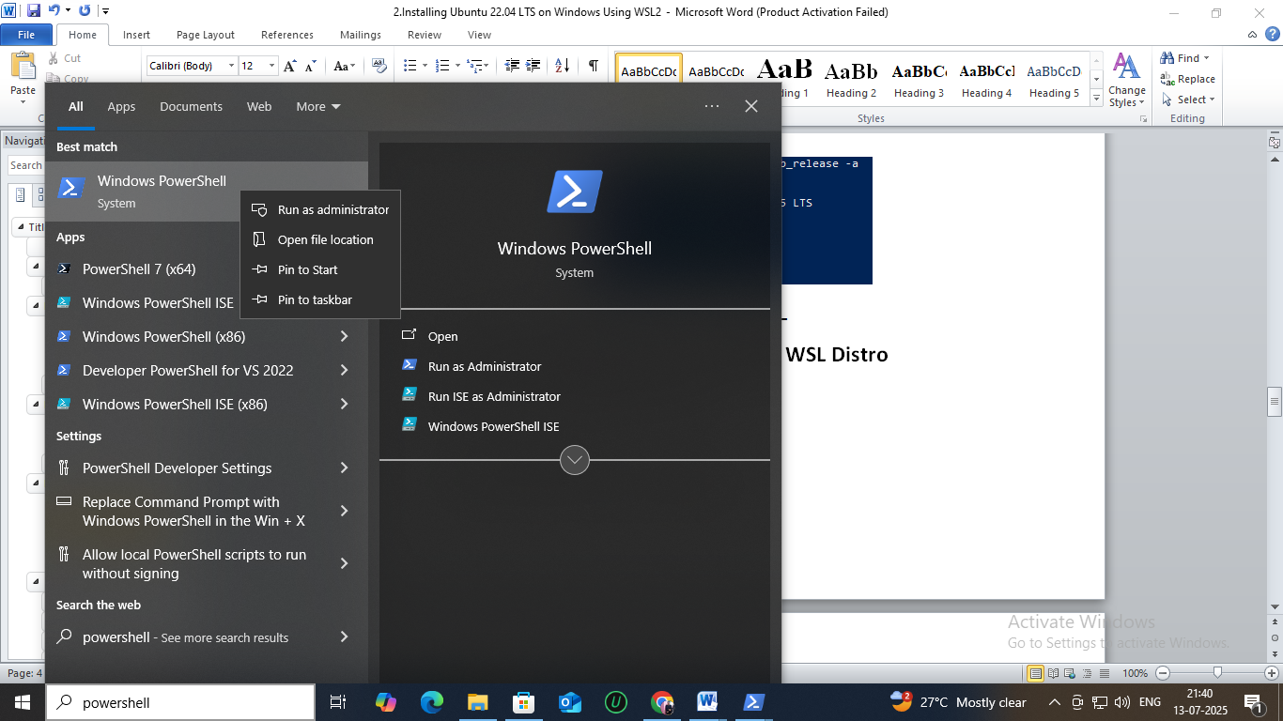

**Step 2: List available Linux distributions**

**wsl --list –online**

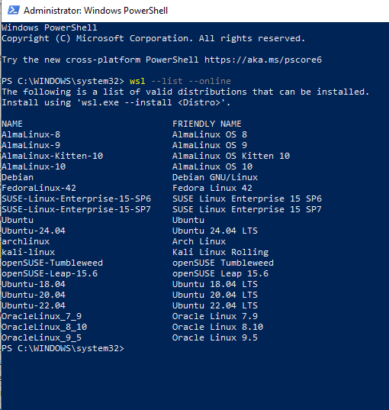

This shows available WSL-compatible Linux distros. Confirm Ubuntu-22.04 is listed.

**Step 3: Install Ubuntu 22.04 LTS**

**wsl --install -d Ubuntu-22.04**

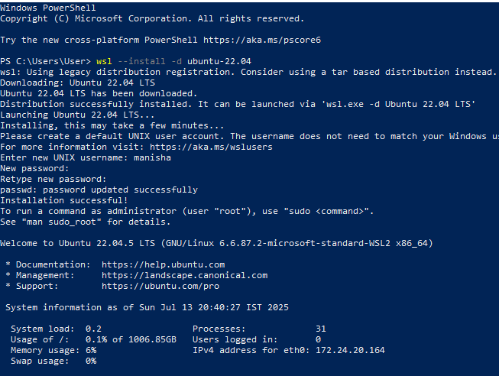

The command will:

* Enable WSL (if not already done),
* Download the Ubuntu 22.04 image,
* Set WSL2 as the default backend.

💡 Note: If asked to reboot, go ahead and restart your computer.

**________________________________________**

**Part 2: Complete Linux Initialization**

**Step 4: Launch Ubuntu and Set Username**

After install and reboot, Ubuntu will open in a terminal.

1. Choose a UNIX **username** (e.g., demoLinux).
2. Set a **password** (used for sudo operations).



**Step 5: Verify Ubuntu version**

In the Ubuntu shell, run:

lsb_release -a

Expected output:

Description: Ubuntu 22.04.4 LTS

Release: 22.04

Codename: jammy

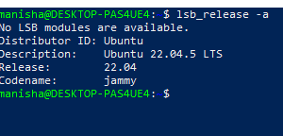

**________________________________________**

**Part 3: Set Ubuntu-22.04 as Default WSL Distro**

**Step 6: Open PowerShell (again as Admin)**



Close the Ubuntu shell.  
Reopen PowerShell with **Run as Administrator**.

**Step 7: Set Ubuntu-22.04 as the default**

wsl --set-default Ubuntu-22.04

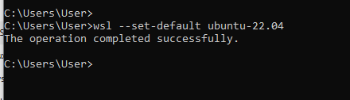

This ensures all future wsl commands launch Ubuntu 22.04.

**Step 8: Confirm it**

wsl --list --verbose

You should see:

NAME STATE VERSION

Ubuntu-22.04 Running 2

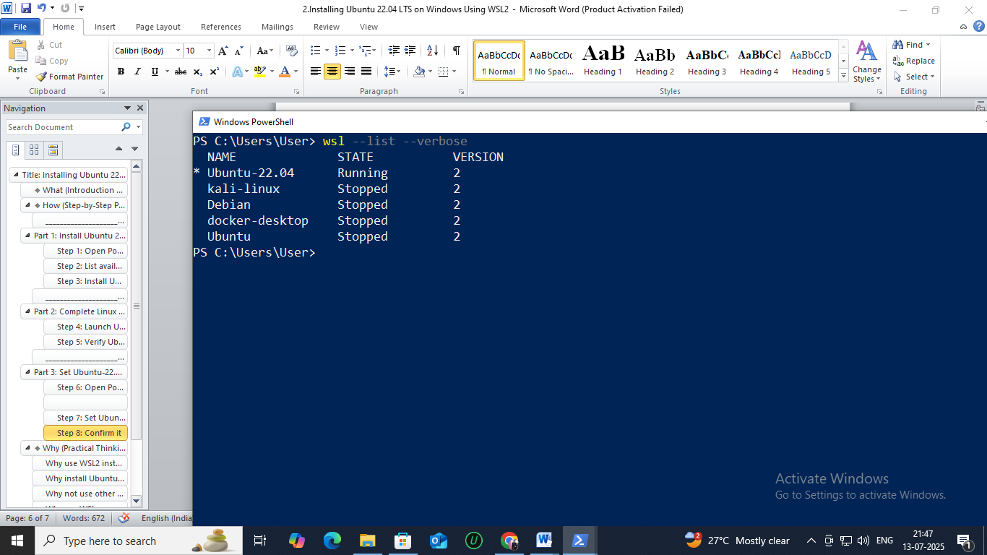

🎉 **Output:**

* Ubuntu 22.04 LTS successfully installed.
* Ubuntu is now the default WSL Linux.
* You're ready to install DevOps tools or start learning Linux commands.

**🔸 Why (Practical Thinking & Reasoning)**

**Why use WSL2 instead of VirtualBox or Dual Boot?**

✔️ Because WSL2 is faster, simpler, and lightweight.  
You don’t need to reboot or configure partitions. It uses fewer resources and supports Docker, making it ideal for DevOps.

**Why install Ubuntu 22.04 LTS specifically?**

✔️ It’s the most widely used, **long-term support** (LTS) Linux version — stable and officially supported by:

* Docker, Kubernetes, GitHub Actions, Jenkins
* AWS, Azure, GCP cloud VMs

**Why not use other distros like Debian or Kali?**

✔️ Debian is good but has older packages.  
✔️ Kali is designed for hacking/pen-testing — **not** for DevOps.  
Ubuntu is the best-supported Linux for real-world DevOps usage.

**Why run WSL commands only in PowerShell?**

✔️ Because the wsl command is part of **Windows**, not Linux.  
Once you’re inside Ubuntu, you can use only Linux commands (ls, cd, apt, etc.).

**Why make Ubuntu-22.04 the default?**

✔️ So wsl opens the correct distro every time.  
You avoid launching an older or unused Linux by mistake.

**Why verify with lsb_release?**

✔️ To confirm that you’re indeed running **Ubuntu 22.04 LTS**, and not some other version like 20.04 or Debian.

**Can I install multiple distros (e.g., Debian, Kali) side by side?**

✔️ Yes. But always set Ubuntu as default if DevOps is your goal.

**What next after this setup?**

✔️ Install DevOps tools like **Git**, **Docker**, **Python**, and start practicing automation and Linux shell scripting.